# NUMERICAL METHODS

LAB ASSIGNMENTS

**Priyank Lohariwal**

**BCSE-II (A2)  
001710501055**

Index

1. Bairstow’s Method

Code………………………………………………………………….4

Output……………………………………………………………….6

1. Bisection Method

Code…………………………………………………………………7

Output………………………………………………………………8

1. Chebysev Method

Code…………………………………………………………………9

Output………………………………………………………………11

1. Fixed Point Iteration Method

Code…………………………………………………………………12

Output………………………………………………………………13

1. Gauss Elimination Method

Code…………………………………………………………………14

Output………………………………………………………………16

1. Gauss’ Central Forward Difference Method

Code…………………………………………………………………17

Output………………………………………………………………19

1. Solving Linear Equations using Gauss Jordan Method

Code…………………………………………………………………20

Output………………………………………………………………21

1. Finding the inverse of a Matrix using Gauss Jordan Method

Code…………………………………………………………………22

Output……………………………………………………………....24

1. Gauss Central Method

Code………………………………………………………………...25

Output……………………………………………………………...26

1. Jacobi’s Method for solving linear equations

Code………………………………………………………………...27

Output………………………………………………………………28

1. Finding Eigen values of a matrix using Jacobi’s Method

Code………………………………………………………………...29

Output……………………………………………………………...30

1. Least square curve fitting method

Code…………………………………………………………………31

Output……………………………………………………………....32

1. LU Decomposition Method

Code…………………………………………………………………33

Output……………………………………………………………....34

1. Modified Euler’s Method

Code………………………………………………………………...35

Output………………………………………………………………36

1. Multi Point Iteration Method

Code……………………………………………………………….37

Output……………………………………………………………..38

1. Newton’s Backward Interpolation Method

Code……………………………………………………………….39

Output……………………………………………………………..40

1. Newton’s Forward Interpolation Method

Code……………………………………………………………….41

Output……………………………………………………………..42

1. Newton’s Forward Difference Method for differentiation

Code……………………………………………………………….43

Output……………………………………………………………..44

1. Newton Raphson Method

Code……………………………………………………………….45

Output…………………………………………………………….46

1. Newton Raphson Method for solving non-linear simultaneous equations

Code……………………………………………………………….47

Output……………………………………………………………..48

1. Power Method

Code……………………………………………………………….49

Output……………………………………………………………..51

1. Regula Falsi Method

Code……………………………………………………………….52

Output…………………………………………………………….53

1. Runge Kutta Method

Code……………………………………………………………….54

Output…………………………………………………………….55

1. Secant Method

Code……………………………………………………………….56

Output…………………………………………………………….57

1. Simpson’s 1/3 Method

Code……………………………………………………………….58

Output…………………………………………………………….59

1. Trapezoidal Method

Code……………………………………………………………….60

Output…………………………………………………………….61

1.Bairstow’s Method

/*Program to apply bairstow's mathod*/

#include<stdio.h>

#include<math.h>

#define max 10

int main(void)

{

FILE *fp;

fp=fopen("1.txt","w");

fprintf(fp," LIN BAIRSTOW METHOD.\n\n");

float a[max], b[max], bc[max], bd[max], p, q, r, s, error, errorp, errorq, rq, sq, rp, sp;

int i, degree, iter=0;

/*accepting the polynomial equation in the following form*/

printf("\n Enter degree of polynomial? ");

scanf("%d",&degree);

fprintf(fp,"The given equation is:\n");

for(i=degree; i>=0; i--)

{

printf("\n Enter coefficient of x^%d: ",i);

if(i<degree)

{

scanf("%f",&a[degree-1-i]);

a[degree-1-i]/=a[degree];

fprintf(fp,"%f * x^%d ",a[degree-1-i],i);

}

else

{

scanf("%f",&a[i]);

fprintf(fp,"%f * x^%d ",a[i],i);

}

}

a[degree]=1;

printf("\n X^2 + PX + Q \n Enter guesses for P and Q: ");

scanf("%f %f",&p,&q);

error=1;

while(error>=0.0005)

{

/* Beginning of Lin's method */

for(i=0;i<=degree-3;i++)

if(i==0)

b[i]=a[i]-p;

else if(i==1)

b[i]=a[i]-p*b[i-1]-q;

else

b[i]=a[i]-p*b[i-1]-q*b[i-2];

/* Modification of Lin's to Bairstow's method */

r = a[degree-2] - p*b[degree-3] - q*b[degree-4];

s = a[degree-1] - q*b[degree-3];

for(i=0; i<=degree-3; i++)

if(i==0)

bc[i]=-1;

else if(i==1)

bc[i]=-b[0]+p;

else

bc[i]=b[i-1]-p*bc[i-1]-q*bc[i-2];

rp=-b[degree-3]-p*bc[degree-3]-q*bc[degree-4];

sp=-q*bc[degree-3];

for(i=0;i<=degree-3;i++)

if(i==0)

bd[i]=0;

else if(i==1)

bd[i]=-1;

else

bd[i]=-b[i-2]-p*bd[i-1]-q*bd[i-2];

rq=-b[degree-4]-p*bd[degree-3]-q*bd[degree-4];

sq=-b[degree-3]-q*bd[degree-3];

errorp = (s*rq - r*sq)/(rp*sq - sp*rq);

p+=errorp;

errorq = (r*sp - s*rp)/(rp*sq - sp*rq);

q+=errorq;

error=errorp>errorq?errorp:errorq;

iter++; /* iteration no. */

}

printf("\n\nA root of the given equation is X^2 + %f*X + %f",p,q);

fprintf(fp,"\n\nA root of the given equation is X^2 + %f*X + %f",p,q);

fclose(fp);}

Output

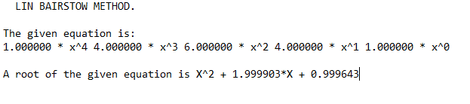

2.Bisection Method

#include<stdio.h>

#include<math.h>

float func(float x) //function to find the value of f(x)

{

float res;

res= exp(-x)-x;

return res;

}

int main(void) //main begins

{

FILE *fp;

fp=fopen("2.txt","w"); //file opens

int iter=1;

float a=-1.0,b=1.0,m,f_a,f_b,f_m,abs_error,multi;

fprintf(fp,"SL.no\t\ta\t\t\tb\t\t\tm\t\t\tf(m)\terror\n");

do //loop for finding the root of the function

{ abs_error=fabs(b-a);

m=(a+b)/2;

f_a=func(a); //calling the function

f_b=func(b);

f_m=func(m);

multi=f_m*f_a;

fprintf(fp,"%d\t\t%f\t%f\t%f\t%f\t%f\n",iter,a,b,m,f_m,multi,abs_error);

if(fabs(f_m)<=0.000005) //checking for required precision

break;

else if(multi<0) b=m;

else a=m;

iter++;

}while(fabs(b-a)>=0.000005); //checking for minimal error

fprintf(fp,"\n\nroot of the function = %f",m); //printing result in file

fclose(fp);

printf("res = %f",m); //printing result in terminal

}

Output

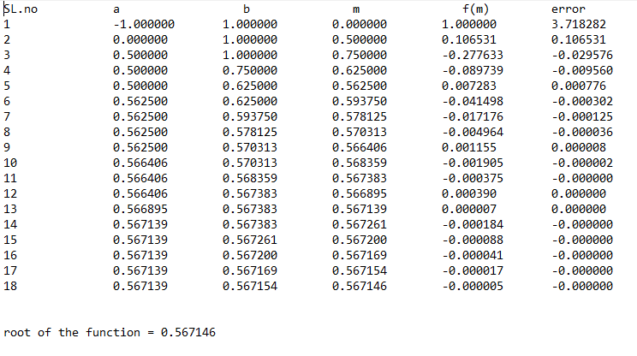

3.Chebysev’s Method

/*Program for describing chebysev method

f(x)= x^3-x-3*/

#include<stdio.h>

#include<math.h>

float func(float x) //function for finding the value of f(x)

{

return (x*x*x-x-3);

}

float dif_func(float x) //function for finding the value of f'(x)

{

return (3*x*x -1);

}

float dDifFunc(float x) //function for finding the value of f"(x)

{

return (6*x);

}

float ri(float r) //function for finding the value of r_next

{

return (r-(func(r)/dif_func(r))-(func(r)*func(r)*dDifFunc(r)/(2*dif_func(r)*dif_func(r)*dif_func(r))));

}

float gf(float x) //function for checking the convergence of the function

{

float res;

res=fabs(func(x)*dDifFunc(x)/((dif_func(x)*dif_func(x))));

return res;

}

int main() //main function begins here

{

int iter=1;

float r_i,r_i1,abs_error,prev_error=0,cond,conv;

printf("Enter the initial point:\n"); //input taken from user

scanf("%f",&r_i);

FILE *fp;

fp=fopen("3.txt","w"); //opening of file in write mode

fprintf(fp,"Sl.no.\t\tr \t\tcondition\t r_next\t\terror\torder of convergence\n");

do //loop for the method

{

cond=gf(r_i);

r_i1=ri(r_i); //updating the value of r_next

abs_error=fabs(r_i1-r_i);

if(prev_error!=0) conv=log(abs_error)/log(prev_error); //finding the order of convergence

prev_error=abs_error;

if(iter==1)

fprintf(fp,"%2d\t\t%9f\t%9f\t%9f\t%9f\t NA\n\n",iter,r_i,cond,r_i1,abs_error);

else

fprintf(fp,"%2d\t\t%9f\t%9f\t%9f\t%9f\t%9f\n\n",iter,r_i,cond,r_i1,abs_error,conv);

iter++;

r_i=r_i1;

}while(abs_error>=0.00001); //checking precision

printf("root of the function=%f\n",r_i1); //printing result

fprintf(fp,"root of the function=%f\n\n",r_i1);

fclose(fp);

return 0;

}

Output

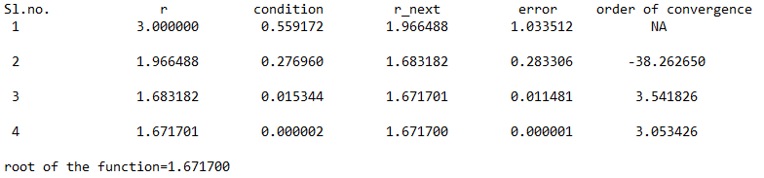

**4. Fixed Point Iteration**

/*Program to apply fixed point iteration*/

#include <stdio.h>

#include <math.h>

#define g(x) exp(-x)

#define dg(x) -exp(-x)

#define f(x) exp(-x)-x //original function f(x)=e^(-x)-x

double x1,e1;

int iter=0;

int main() //main begins

{

FILE *fp; //opening file pointer

fp=fopen("4.txt","w");

double x,order,e;

printf("Enter the starting point:");

scanf("%lf",&x); //taking initial input from the user

fprintf(fp,"SL\t\tx\t\tg(x)\t\tdg(x)\t\tf(x)\t\terror\t\torder\n");

do //loop to apply the method

{

iter++;

if (fabs(dg(x))>1) //checking for convergence

{

printf("the process may not converge to the root\n");

return 0;

}

x1=g(x);

e=fabs(x1-x);

if(iter==1)

fprintf(fp,"%d\t%9f\t%9f\t%9f\t%9f\t%9f\tNA\n",iter,x,g(x),dg(x),f(x),e,order);

else //finding order of convergence

{

order=log(e)/log(e1);

fprintf(fp,"%d\t%9f\t%9f\t%9f\t%9f\t%9f\t%9f\n",iter,x,g(x),dg(x),f(x),e,order);

}

e1=e;

x=x1;

}while(e>0.00005); //checking the precision

printf("The root of the equation is %f\n",x1); //printing final result

fprintf(fp,"\n\nThe root of the equation is %f\n",x1);

fclose(fp);

return 0;}

Output

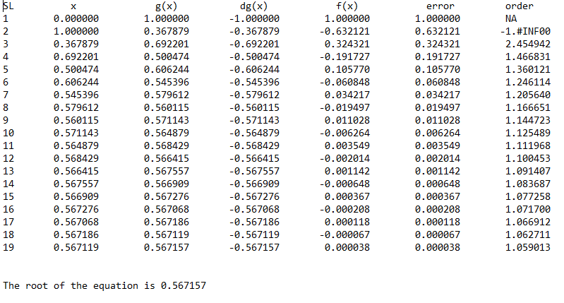

**5. Gauss Elimination Method**

/*Program to find the solution of linear equations using gauss elimination method*/

#include <stdio.h>

#include <stdlib.h>

#include <math.h>

void Gauss_Elimination(); //function prototype

int main(void)

{

Gauss_Elimination(); //calling function inside main function

}

void Gauss_Elimination()

{ int n,i,j,k,p; //variable decleration

FILE *fp;

fp=fopen("5.txt","w");

fprintf(fp," GAUSSIAN ELIMINATION FOR SOLVING LINEAR EQUATIONS.\n\n");

printf("Enter number of variables:");

scanf("%d",&n); //size of matrix

float a[n+1][n+2],m[n][n+2],sum,big,temp,x[n+1]; //variable decleration

big=0;

for(i=1;i<=n;i++){

x[i] = 0;

}

fprintf(fp,"Augmented matrix formed is:\n");

printf("Enter the augmented matrix.\n");

for(i=1;i<=n;i++){

for(j=1;j<=n+1;j++){

scanf("%f",&a[i][j]); //value giving for matrix

fprintf(fp,"%f\t",a[i][j]);

}

fprintf(fp,"\n");

}

for(k=1;k<n;k++)

{

big = 0;

for(i=k;i<n;i++) //partial pivoting

{

if(fabs(a[i][k])>big)

{

big = fabs(a[i][k]);

p = i;

}

}

for(j=k;j<=n+1;j++) //swapping values

{

temp = a[k][j];

a[k][j] = a[p][j];

a[p][j] = temp;

}

for(i = k+1;i<=n;i++)

{ //gauss elimination

m[i][k] = a[i][k] / a[k][k];

for(j=k;j<=n+1;j++)

{

a[i][j] = a[i][j] - m[i][k]*a[k][j];

}

}

}

for(i =n;i>=1;i--)

{

sum = 0;

for(j = n;j>=i;j--) //back substitution

{

sum = sum + a[i][j]*x[j];

}

x[i] = (a[i][n+1] -sum)/a[i][i]; //solving and finding values

}

for(i = 1;i<=n;i++)

{

printf("x%d = %f",i,x[i]); //print the result

fprintf(fp,"x%d = %f",i,x[i]);

printf("\n");

fprintf(fp,"\n");

}

for(i=1;i<=n;i++){

for(j=1;j<=n+1;j++){

printf("%f ",a[i][j]); //print the upper tringualr matrix after gauss elimination

fprintf(fp,"%f ",a[i][j]);

}

printf("\n");

fprintf(fp,"\n");

}

fclose(fp);

}

Output

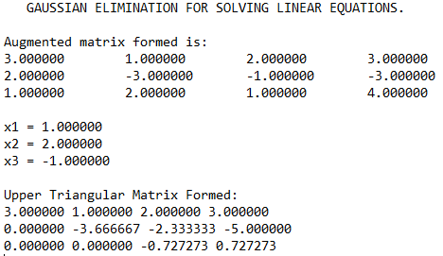

**6. Gauss Central Forward Difference Method**

/*

Program to implement GAUSS' FORWARD INTERPOLATION FORMULA.

---------------------------------

*/

#include<stdio.h>

#include<math.h>

void main()

{

FILE *fp;

fp=fopen("6.txt","w");

fprintf(fp,"GAUSS CENTRAL FORWARD INTERPOLATION.\n\n");

int n,i,j;

float y1,y2,y3,y4,x,nr,dr,y=0,h,p;

float diff[20][20];

// Input section.

printf("\n\n Enter the no. of terms: ");

scanf("%d",&n);

float ax[n],ay[n];

// Input Sequel for array X and Y

printf("\n\n Enter the value in the form of x f(x)\n ");

// Input loop for X and Y

for(i=0;i<n;i++)

scanf("%f%f",&ax[i],&ay[i]);

// Inputting the required value query

printf("\n\n Enter the required value of x.\n ");

scanf("%f",&x);

// Calculation and processing section.

h=ax[1]-ax[0];

for(i=0;i<n-1;i++)

diff[i][1]=ay[i+1]-ay[i];

for(j=2;j<=4;j++)

for(i=0;i<n-j;i++)

diff[i][j]=diff[i+1][j-1]-diff[i][j-1];

fprintf(fp,"x\t\t\tDifference Table\n");

for(i=0;i<n;i++) //difference table printed

{

fprintf(fp,"%f|\t",ax[i]);

fprintf(fp,"%f\t",ay[i]);

for(j=1;j<n-i;j++)

fprintf(fp,"%f\t",diff[i][j]);

fprintf(fp,"\n");

}

i=0;

//Implementation of the method performed here after

do

{

i++;

}while(ax[i]<x);

i--;

p=(x-ax[i])/h;

y1=p*diff[i][1];

y2=p*(p-1)*diff[i-1][2]/2;

y3=(p+1)*p*(p-1)*diff[i-2][3]/6;

y4=(p+1)*p*(p-1)*(p-2)*diff[i-3][4]/24;

// Taking sum

y=ay[i]+y1+y2+y3+y4;

// Outut Section

printf("\n When x = %6.4f , y = %6.8f\n",x,y);

fprintf(fp,"\n\nResult:\tf(%f)=%f",x,y); //final result printed in the file

fclose(fp);

}

Output

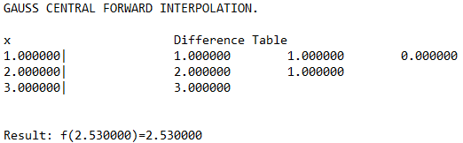

**7. Gauss Jordan Method**

/*Program to solve linear equations using gauss jordan method*/

#include<stdio.h>

#include<math.h>

void pivot(double a[100][100], int, int);

int main()

{

FILE *fp;

fp=fopen("7.txt","w");

int i,j,k,n,maxpos,l,ch,loop1,loop2;

double m,s,temp,max;

printf("Enter Value of n:\n"); //number of variables is scanned

scanf("%d", &n);

printf("Enter the augmented matrix:\n"); //augmented matrix is taken from the user

fprintf(fp,"The augmented matrix is:\n");

double a[n][n+1], x[n];

for(i=0; i<n; i++)

{

for(j=0; j<=n; j++){

scanf("%lf", &a[i][j]);

fprintf(fp,"%lf", &a[i][j]);

}

fprintf(fp,"\n");

}

for(k=0; k<n; k++) //loop for the implementation of the method

{

for(i=0; i<n; i++){

if(i==k)

continue;

m=a[i][k]/a[k][k];

for(j=k; j<n+1; j++)

a[i][j]= a[i][j]-(m*a[k][j]);

}

}

printf("\n");

fprintf(fp,"\n");

for(i=0; i<n; i++)

{

printf("\n");

fprintf(fp,"\n");

for(j=0; j<=n; j++)

{

printf("%lf ", a[i][j]);

fprintf(fp,"%lf ", a[i][j]);

}

}

for(i=0; i<n; i++)

{

x[i]=a[i][n]/a[i][i];

}

printf("\n\nSolution to the Equation:\n"); //printing the results

fprintf(fp,"\n\nSolution to the Equation:\n");

for(i=0; i<n; i++){

printf("%lf\n", x[i]);

fprintf(fp,"%lf\n",x[i]);

}

fclose(fp);

return 0;

}

Output

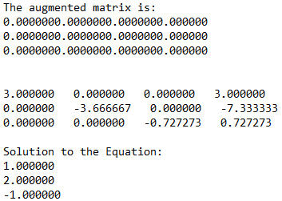

**8. Gauss Jordan Method(for finding inverse of a matrix)**

/*Program to find inverse of a given matrix*/

#include<stdio.h>

int main() //main begins here

{

FILE *fp;

fp=fopen("8.txt","w");

fprintf(fp," GAUSS JORDAN METHOD FOR FINDING INVERSE OF A MATRIX.\n\n");

int iter1, iter2, k, order;

printf("Enter order of matrix: ");

scanf("%d", &order); //taking the input for the oder of the matrix

float matrix[order][order*2], ratio,a;

printf("Enter the matrix: \n");

fprintf(fp,"The matrix is:\n\n");

for(iter1 = 0; iter1 < order; iter1++) //taking the input for the matrix

{

for(iter2 = 0; iter2 < order; iter2++)

{

scanf("%f", &matrix[iter1][iter2]);

fprintf(fp,"%f\t",matrix[iter1][iter2]);

}

fprintf(fp,"\n");

}

for(iter1 = 0; iter1 < order; iter1++) //making an identity matrix

{

for(iter2 = order; iter2 < 2*order; iter2++)

{

if(iter1==(iter2%order))

matrix[iter1][iter2] = 1.0;

else

matrix[iter1][iter2] = 0.0;

}

}

for(iter2=0; iter2<order; iter2++)

{

int temp=iter2;

/* finding maximum jth column element in last (dimension-j) rows */

for(iter1=iter2+1; iter1<order; iter1++)

if(matrix[iter1][iter2]>matrix[temp][iter2])

temp=iter1;

/* swapping row which has maximum jth column element */

if(temp!=iter2)

for(k=0; k<2*order; k++)

{

float temporary=matrix[iter2][k] ;

matrix[iter2][k]=matrix[temp][k] ;

matrix[temp][k]=temporary ;

}

/* performing row operations to form required identity matrix out of the input matrix */

for(iter1=0; iter1<order; iter1++)

if(iter1!=iter2)

{

ratio=matrix[iter1][iter2];

for(k=0; k<2*order; k++)

matrix[iter1][k]-=(matrix[iter2][k]/matrix[iter2][iter2])*ratio ;

}

else

{

ratio=matrix[iter1][iter2];

for(k=0; k<2*order; k++)

matrix[iter1][k]/=ratio ;

}

}

fprintf(fp,"\nThe inverse of the given matrix is:\n");

printf("The inverse matrix is: \n"); //printing the final result

for(iter1 = 0; iter1 < order; iter1++){

for(iter2 = order; iter2 < 2*order; iter2++)

{

printf("%f\t", matrix[iter1][iter2]);

fprintf(fp,"%f\t",matrix[iter1][iter2]);

}

printf("\n");

fprintf(fp,"\n");

}

fclose(fp);

return 0;

}

Output

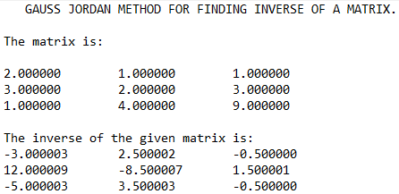

**9. Gauss Seidel Method**

/*Program for implementing Gauss seidel method*/

#include<stdio.h>

#include<math.h>

int main(void) //main begins here

{

FILE *fp;

fp=fopen("9.txt","w");

fprintf(fp," GAUSS SEIDEL METHOD.\n\n");

int order,i,j,k;

printf("Enter the number of variables\n");

scanf("%d",&order); //scans the number of variables

float A[order][order+1],x[order],x_new[order],error;

for(i=0;i<order;i++) //seeding the initial result

{

x[i]=0;x_new[i]=0;

}

printf("Enter the augmented matrix\n");

fprintf(fp,"The augmented matrix is:-\n");

for(i=0;i<order;i++){ //augmented matrix is scanned from the user row-wise

for(j=0;j<order+1;j++){

scanf("%f",&A[i][j]);

fprintf(fp,"%f\t",A[i][j]);

}fprintf(fp,"\n");

}

do //loop for implementing the method

{

for(i=0;i<order;i++)

{

x_new[i]=A[i][order]; //updating the value of x begins here

for(j=0;j<i;j++)

{

x_new[i]-=A[i][j]*x_new[j];

}

for(j=i+1;j<order;j++)

{

x_new[i]-=A[i][j]*x[j];

}

x_new[i]/=A[i][i];

}

error=fabs(x_new[0]-x[0]); //error calculation

for(i=0;i<order;i++)

{

if(error>fabs(x_new[i]-x[i])) error=fabs(x_new[i]-x[i]);

}

for(i=0;i<order;i++) x[i]=x_new[i];

}while(error>=0.00001); //minimum error calculation

printf("The solution set is:\n"); //printing the results

fprintf(fp,"The solution set is:\n");

for(i=0;i<order;i++){

printf("%0.5f\t",x[i]);

fprintf(fp,"%0.5f\t",x[i]);

}

printf("\n");

fclose(fp);

}

Output

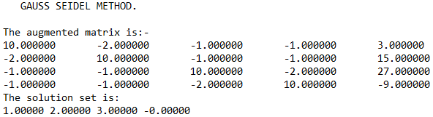

**10. Jacobi’s Method**

/*Program for implementing Jacobi's method*/

#include<stdio.h>

#include<stdlib.h>

#include<math.h>

int main(void) //main begins here

{

FILE *fp;

fp=fopen("10.txt","w");

fprintf(fp," JACOBI METHOD FOR SOLVING EQUATIONS.\n\n");

int order,i,j,k;

printf("Enter the number of variables\n");

scanf("%d",&order); //scans the number of variables

float A[order][order+1],x[order],x_new[order],error,max;

for(i=0;i<order;i++) //seeding the initial result

{

x[i]=0;x_new[i]=0;

}

printf("Enter the augmented matrix\n");

fprintf(fp,"The augmented matrix is:-\n");

for(i=0;i<order;i++){ //augmented matrix is scanned from the user row-wise

for(j=0;j<order+1;j++){

scanf("%f",&A[i][j]);

fprintf(fp,"%f\t",A[i][j]);

}fprintf(fp,"\n");

}

do //loop for implementing the method

{

for(i=0;i<order;i++)

{

x_new[i]=A[i][order]; //updating the value of x begins here

for(j=0;j<order;j++)

{

if(j!=i) x_new[i]-=A[i][j]*x[j];

}

x_new[i]/=A[i][i];

}

max=fabs(x_new[0]-x[0]); //error calculation

for(i=0;i<order;i++)

{

error=fabs(x_new[i]-x[i]);

if(error>max) max=error;

}

for(i=0;i<order;i++) x[i]=x_new[i];

}while(max>=0.000005); //minimum error calculation

printf("The solution set is:\n"); //printing the results

fprintf(fp,"The solution set is:\n");

for(i=0;i<order;i++){

printf("%0.5f\t",x[i]);

fprintf(fp,"%0.5f\t",x[i]);

}

printf("\n");

fclose(fp);

}

Output

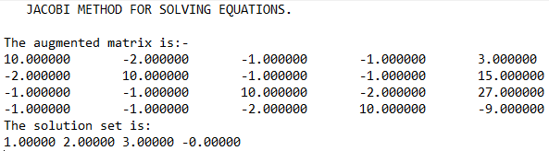

**11.** **Finding Eigen values of a matrix using Jacobi’s Method**

/*Program to find eigen value using jacobi's method*/

#include<stdio.h>

#include<math.h>

int main(void)

{

FILE *fp;

fp=fopen("11.txt","w");

fprintf(fp," Finding Eigen value using Jacobi's method\n\n");

int i,j,n,r,s;

printf("Enter the order of the matrix\n");

scanf("%d",&n);

float x[n][n],max=0,sum=0;

printf("Enter the symmetrix of order %d\n",n);

fprintf(fp,"The given matrix is:\n");

for(i=0;i<n;i++)

for(j=0;j<n;j++)

{

scanf("%f",&x[i][j]);

fprintf(fp,"%f\t",x[i][j]);

if(j>i)

{

sum+=x[i][j];

if(max<fabs(x[i][j]))

{

max=x[i][j];r=i;s=j;

}

}

fprintf(fp,"\n");

}

while(sum!=0)

{

float ang=atan((2*x[r][s])/(x[r][r]-x[s][s]))/2;

for(i=0;i<n;i++)

for(j=0;j<n;j++)

{

if(j>i && j!=r &&j!=s)

{

x[j][r]=x[j][r]*cos(ang)+x[j][s]*sin(ang);

x[r][j]=x[j][r];

x[j][s]=x[j][s]*cos(ang)-x[j][r]*sin(ang);

x[s][j]=x[j][s];

}

}

x[r][r]=x[r][r]*cos(ang)*cos(ang)+2*x[r][s]*cos(ang)*sin(ang)+x[s][s]*sin(ang)*sin(ang);

x[s][s]=x[s][s]*cos(ang)*cos(ang)-2*x[r][s]*cos(ang)*sin(ang)+x[r][r]*sin(ang)*sin(ang);

x[r][s]=0;x[s][r]=0;

max=0,sum=0;

for(i=0;i<n;i++)

for(j=0;j<n;j++)

{

if(j>i)

{

sum+=x[i][j];

if(max<fabs(x[i][j]))

{

max=x[i][j];r=i;s=j;

}

}

}

printf("%f\n",sum);

}

printf("The eigen values are:\n");

fprintf(fp,"The eigen values are:\n");

for(i=0;i<n;i++){

printf("%f\n",x[i][i]);

fprintf(fp,"%f\n",x[i][i]);}}

Output

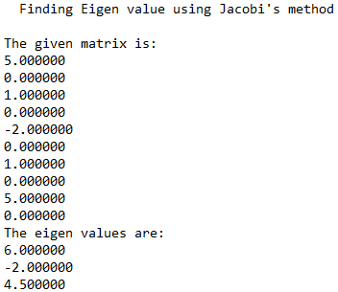

**12. Curve Fitting using Least Squares Method**

/*Program for applying least square method of curve fitting*/

#include<stdio.h>

#include<math.h>

int main() //main begins here

{

FILE *fp; //file pointer declared

fp=fopen("12.txt","w"); //file opened

fprintf(fp," Linear Curve fitting using least square method\n\n");

int n,i, x[20],y[20],sumx=0,sumy=0,sumxy=0,sumx2=0; //variables declared

float a,b;

printf("\n Enter the value of number of terms n:"); //scanning begins from here

scanf("%d",&n);

printf("\n Enter the values of x:\n");

for(i=0;i<=n-1;i++)

{

scanf(" %d",&x[i]);

}

printf("\n Enter the values of y:");

fprintf(fp,"Given inputs are:\n");

for(i=0;i<=n-1;i++)

{

scanf("%d",&y[i]);

fprintf(fp," f(%d)=%d\n",x[i],y[i]);

}

for(i=0;i<=n-1;i++) //calculation of the function

{

sumx=sumx +x[i];

sumx2=sumx2 +x[i]*x[i];

sumy=sumy +y[i];

sumxy=sumxy +x[i]*y[i];

}

a=((sumx2*sumy -sumx*sumxy)*1.0/(n*sumx2-sumx*sumx)*1.0); //final sum calculated

b=((n*sumxy-sumx*sumy)*1.0/(n*sumx2-sumx*sumx)*1.0);

printf("\n\nThe line is Y=%3.3fx +%3.3f \n",b,a); //final result being printed here

fprintf(fp,"\n\nThe line is Y=%3.3fx +%3.3f \n",b,a);

fclose(fp);

return 0;

}

Output

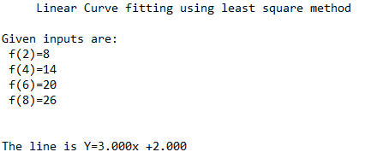

**13. LU Decomposition Method**

/*Program to implement LU decomposition method*/

#include<stdio.h>

int main(void) //main begins here

{

FILE *fp;

fp=fopen("13.txt","w");

fprintf(fp," LU Decomposition method.\n\n");

int size,i,j,p,k;

printf("Enter the order of the matrix.\n");

scanf("%d",&size); //size of the matrix scanned from the terminal

float A[size][size],L[size][size],U[size][size];

printf("Enter the matrix.\n"); //matrix is scanned

fprintf(fp,"A:");

for(i=0;i<size;i++){

for(j=0;j<size;j++){

scanf("%f",&A[i][j]);

fprintf(fp,"%f\t",A[i][j]);

}

fprintf(fp,"\n ");

}

for(i=0;i<size;i++) //matrices initialised

for(j=0;j<size;j++)

{

L[i][j]=0;U[i][j]=0;

}

for(j=0;j<size;j++) //loop of implementation

for(i=0;i<size;i++)

{

if(i>=j) //for lower matrix

{

L[i][j]=A[i][j];

for(k=0;k<=j-1;k++) L[i][j]-=L[i][k]*U[k][j];

if(i==j) U[i][j]=1;

}

else //for upper matrix

{

U[i][j]=A[i][j];

for(k=0;k<=i-1;k++)

U[i][j]-=L[i][k]*U[k][j];

U[i][j]/=L[i][i];

}

}

printf("\nL\n"); //printing results

fprintf(fp,"\nL:");

for(i=0;i<size;i++)

{

for(j=0;j<size;j++){

printf("%f\t",L[i][j]);

fprintf(fp,"%f\t",L[i][j]);

}

printf("\n");

fprintf(fp,"\n ");

}

printf("\nU\n");

fprintf(fp,"\nU:");

for(i=0;i<size;i++)

{

for(j=0;j<size;j++){

printf("%f\t",U[i][j]);

fprintf(fp,"%f\t",U[i][j]);

}

fprintf(fp,"\n ");

printf("\n");

}

fclose(fp);

}

Output

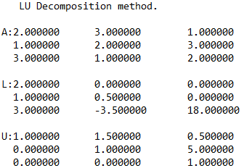

**14. Modified Euler’s Method**

a/*Program to apply modified euler's method for solving linear differential equation*/

#include<stdio.h>

#include<math.h>

#define fun(x,y) y-x //function used is y'=y-x

void main() //main begins here

{

FILE *fp;

fp=fopen("modified euler.txt","w");

fprintf(fp," Modified euler method for solving differential equation.\n\nDE: y'=y-x\n\n");

int i,j,c;

float x,y,h,m,m1,m2,a,s[100],w;

printf(" Enter the value of x0,xn,h,y0:\n"); //initial and final values of x, height of x and initial value of y is taken as input

scanf("%f%f%f%f",&x,&a,&h,&y);

s[0]=y;

printf(" The respective values of x and y are\n x \t y\n\n");

fprintf(fp," The respective values of x and y are\n x \t y\n\n");

for(i=1;x<a;i++) //method application here

{

printf(" %f\t%f\n",x,y);

fprintf(fp," %f\t%f\n",x,y);

w=100;

m=fun(x,y);

x= x+h;

c=0;

while(w>0.00001) //convergence of y at ith iteration

{

m1=fun(x,s[c]);

m2=(m+m1)/2;

s[c+1]=y+m2*h;

w=fabs(s[c]-s[c+1]);

c++;

}

y=s[c];

}

printf(" %f\t%f\n",x,y);

fprintf(fp," %f\t%f\n",x,y); //printing final results

fclose(fp);

}

Output

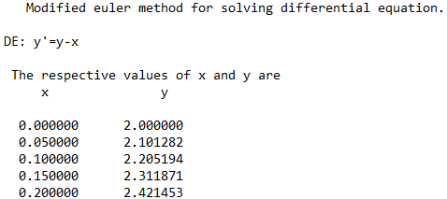

**15. Multi Point Iteration Method**

/*Program to apply multi point iteration method to find the root of the equation e^x-2x-1*/

#include<stdio.h>

#include<math.h>

double f(double x) //function to return f(x)

{

double y;

y=exp(x)-2*x-1;

return y;

}

double df(double x) //function to return f'(x)

{

double y;

y=exp(x)-2;

return y;

}

double soln(double r) //fuunction to return root of the equation using multipoint iteration method

{

int i=1;

double ri,ri_s,pre_err,err,order=0;

FILE *fp; //opening the file

fp=fopen("15.txt","w");

fprintf(fp," MULTI POINT ITERATION METHOD.\n\n");

pre_err=0;

err=0;

ri_s=r-(f(r)/(2*df(r))); //calculating ri+1*

ri=r-(f(r)/df(ri_s)); //calculating ri+1

pre_err=fabs(r-ri);

fprintf(fp,"i x f(x) a_error order");

fprintf(fp,"\n%d %lf %lf %lf %lf",i,r,f(r),pre_err,order);

while(fabs(r-ri)>=0.0001) //doing the iteration till error becomes less than 10^-4

{

r=ri;i++;

ri_s=r-(f(r)/(2*df(r))); //calculating ri+1*

ri=r-f(r)/df(ri_s); //calculating ri+1

err=fabs(r-ri); //calculating error

order=log(err)/log(pre_err); //calculating order of convergence

fprintf(fp,"\n%d %lf %lf %lf %lf",i,r,f(r),err,order);//printing results

pre_err=err; //updating previous error

}

fprintf(fp,"\n\nThe root of the equaion is %lf\n",r); //printing the final result

fclose(fp); //closing the file

return r; //returning the root

}

/*main begins here*/

void main()

{

double r;

printf("enter any starting point:"); //taking input from the user

scanf("%lf",&r);

printf("\nroot=%lf",soln(r)); //printing the result by calling the function

}

Output

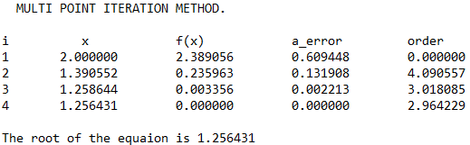

**16. Newton’s Backward Difference Interpolation Method**

/*Program to implement backward interpolation technique*/

#include<stdio.h>

#include<math.h>

int fact(int n) //function to find the factorial of n

{

int f=1,i;

for(i=2;i<=n;i++)

f*=i;

return f;

}

int main(void) //main begins

{

FILE *fp;

fp=fopen("16.txt","w"); //file opened to print the data in it

printf("Enter the number of inputs.\n");

int n,i,j;

scanf("%d",&n);

printf("Enter the values of the function as x,f(x)\n"); //inputs taken

float x[n];

float y[n][n];

for(i=0;i<n;i++)

scanf("%f%f",&x[i],&y[i][0]);

for(i=1;i<n;i++) //difference table created

for(j=n-1;j>=i;j--)

y[j][i]=y[j][i-1]-y[j-1][i-1];

fprintf(fp," x\t\t Difference table.\n");

for(i=0;i<n;i++) //difference table printed

{

fprintf(fp,"%f\t",x[i]);

for(j=0;j<=i;j++)

fprintf(fp,"%f\t",y[i][j]);

fprintf(fp,"\n");

}

float val; //interpolated value taken from the user

printf("Enter the value to interpolat at:(between %f and %f)\n",x[0],x[n-1]);

scanf("%f",&val);

float sum=y[n-1][0];

float u=(val-x[n-1])/(x[1]-x[0]); //height is found

float temp=u;

for(i=1;i<n;i++)

{

sum+=((u*y[n-1][i])/fact(i)); //formula of the technique implemented here

u*=(temp+i);

}

printf("Value at %f is %f\n",val,sum); //final result printed in the terminal and the file

fprintf(fp,"\n\n\nf(%f)=%f\n",val,sum);

}

Output

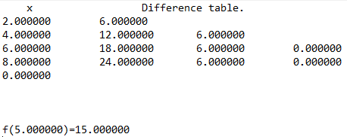

**17. Newton’s Forward Difference Interpolation Method**

/*Program to implement forward interpolation technique*/

#include<stdio.h>

#include<math.h>

int fact(int n) //function to find the factorial of n

{

int f=1,i;

for(i=2;i<=n;i++)

f*=i;

return f;

}

int main(void) //main begins

{

FILE *fp;

fp=fopen("17.txt","w"); //file opened to print the data in it

int n=4,i,j;

printf("Enter the values of the function as x,f(x)\n"); //inputs taken

float x[4];

float y[4][4];

for(i=0;i<4;i++)

scanf("%f%f",&x[i],&y[i][0]);

for(i=1;i<n;i++) //difference table created

for(j=0;j<n-i;j++)

y[j][i]=y[j+1][i-1]-y[j][i-1];

fprintf(fp," x\t\t f(x)\t\t df(x)\t\td1f(x) \td2f(x)\n");

for(i=0;i<n;i++) //difference table printed

{

fprintf(fp,"%f\t",x[i]);

for(j=0;j<n-i;j++)

fprintf(fp,"%f\t",y[i][j]);

fprintf(fp,"\n");

}

float val; //interpolated value taken from the user

printf("Enter the value to interpolat at:(between %f and %f)\n",x[0],x[3]);

scanf("%f",&val);

float sum=y[0][0];

float u=(val-x[0])/(x[1]-x[0]); //height is found

for(i=1;i<n;i++)

{

sum+=(u*y[0][i])/fact(i); //formula of the technique implemented here

u*=(u-1);

}

printf("Value at %f is %f\n",val,sum); //final result printed in the terminal and the file

fprintf(fp,"\n\n\nf(%f)=%f\n",val,sum);

}

Output

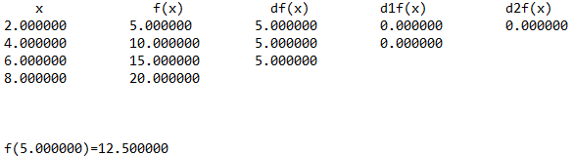

**18. Newton’ Forward Difference Formula for differentiation**

/*Program for applying newton forward difference formula for differentiation*/

#include<stdio.h>

#include<math.h>

int fact(int n) //function to find the factorial of n

{

int f=1,i;

for(i=2;i<=n;i++)

f*=i;

return f;

}

int main()

{

FILE *fp; //file pointer declared

fp=fopen("18.txt","w");

int n,i,j;

printf("Enter the number of terms.\n");

scanf("%d",&n);

float x[n],y[n][n]; //variables declared

for(i=0;i<n;i++) //inputs taken from the user

scanf("%f%f",&x[i],&y[i][0]);

for(i=1;i<n;i++) //difference table created

for(j=0;j<n-i;j++)

y[j][i]=y[j+1][i-1]-y[j][i-1];

fprintf(fp," x\t\t f(x)\t\t df(x)\t\td1f(x) \td2f(x)\n");

for(i=0;i<n;i++) //difference table printed

{

fprintf(fp,"%f\t",x[i]);

for(j=0;j<n-i;j++)

fprintf(fp,"%f\t",y[i][j]);

fprintf(fp,"\n");

}

float sum=0;

for(i=0;i<n-1;i++) //formula for the method

sum+=pow(-1,i)*y[0][i+1]/fact(i+1);

sum/=(x[1]-x[0]); //printing the final result

printf("The f'(%f) = %f\n",x[0],sum);

fprintf(fp,"\n\n\tThus, f'(%f) = %f\n",x[0],sum);

fclose(fp); //file pointer closed

}

Output

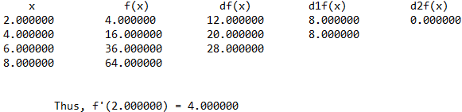

**19. Newton Raphson Method**

/*Program for describing newton raphson method

f(x)= x^3-x-3*/

#include<stdio.h>

#include<math.h>

float func(float x) //function for finding the value of f(x)

{

return (x*x*x-2*x-5);

}

float dif_func(float x) //function for finding the value of f'(x)

{

return (3*x*x -2);

}

float dDifFunc(float x) //function for finding the value of f"(x)

{

return (6*x);

}

float ri(float r) //function for finding the value of r_next

{

return (r-(func(r)/dif_func(r)));

}

float gf(float x) //function for checking the convergence of the function

{

float res;

res=fabs(func(x)*dDifFunc(x)/((dif_func(x)*dif_func(x))));

return res;

}

int main() //main function begins here

{

int iter=1;

float r_i,r_i1,abs_error,prev_error=0,cond,conv;

printf("Enter the initial point:\n"); //input taken from user

scanf("%f",&r_i);

FILE *fp;

fp=fopen("19.txt","a"); //opening of file in write mode

fprintf(fp," NEWTON RAPHSON METHOD\n\n");

fprintf(fp,"Sl.no.\tr\t\t\tcondition\tr_next\t\terror\t\torder of convergence\n");

do //loop for the method

{

cond=gf(r_i);

if(cond>1) //checking the divergency of the function

{

printf("function diverges!!\nProgram failed!!!!\n"); // if diverges,program fails

fprintf(fp,"Function diverges!!\n\n\n");fclose(fp);return 0;

break;

}

r_i1=ri(r_i); //updating the value of r_next

abs_error=fabs(r_i1-r_i);

if(prev_error!=0) conv=log(abs_error)/log(prev_error); //finding the order of convergence

prev_error=abs_error;

if(iter==1)

fprintf(fp,"%d\t\t%f\t%f\t%f\t%f\tNA\n\n",iter,r_i,cond,r_i1,abs_error);

else

fprintf(fp,"%d\t\t%f\t%f\t%f\t%f\t%f\n\n",iter,r_i,cond,r_i1,abs_error,conv);

iter++;

r_i=r_i1;

}while(abs_error>=0.00001); //checking precision

printf("root of the function=%f",r_i1); //printing result

fprintf(fp,"root of the function=%f",r_i1);

fclose(fp);

return 0;

}

Output

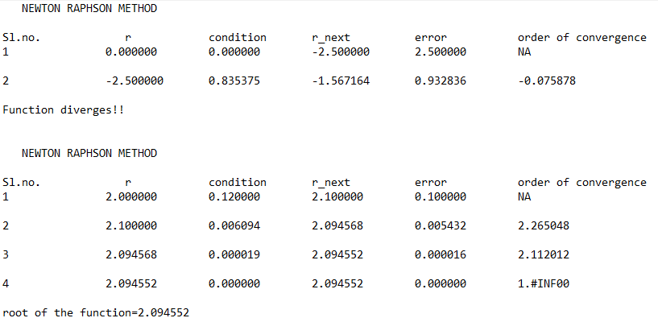

20. Newton Raphson method for solving non-linear simultaneous equations

/*Program to implement Newton raphson mathod for solving non linear simultaneous equations*/

#include<stdio.h>

#include<math.h>

#define f(x,y) x*x-y*y-3 //first equation as f(x,y)=0

#define g(x,y) x*x+y*y-13 //second equation as g(x,y)=0

#define max(x,y) x>y?x:y //max function

//main begins

int main(void)

{

FILE *fp;

fp=fopen("20.txt","w");

fprintf(fp," Newton Raphson method for solving non-linear simultaneous equations\n\n");

fprintf(fp,"Functions:\nf(x,y)=x^2-y^2-3\ng(x,y)=x^2+y^2-13\n\n");

int iter=0;

float x,y,h,k,pfx,pfy,pgx,pgy,f0,g0,jac;

x=sqrt(6.5); //initialisation of x,y for making g(x,y)=0;

y=x;

fprintf(fp,"Sl\t\th\t\t\tk\t\t x\t\t\ty\t\tjacobian term\n");

do

{

iter++; //for printing the iterations

f0=f(x,y); //function values

g0=g(x,y);

pfx=2*x; //partial derivatives of functions w.r.t variable

pfy=-2*y;

pgx=2*x;

pgy=2*y;

jac=pfx*pgy-pfy*pgx; //value of jacobian

/*h and k are approximation to the value of x and y calculated by solving the equations

h(pfx)+k(pfy)=f0 and

h(pgx)+k(pgy)=g0*/

h=(pfy*g0-pgy*f0)/(pfx*pgy-pfy*pgx); //extending limits of x

k=(pgx*f0-pfx*g0)/(pfx*pgy-pfy*pgx); //extending limits of y

x=x+h;

y=y+k;

fprintf(fp,"%d\t%f\t%f\t%f\t%f\t%f\n",iter,h,k,x,y,jac); //printing value of x and y in each iteration

}while((max(f(x,y),g(x,y))>=0.0005)&&jac!=0); //loop shall run till functions tend to 0

printf("Results:\nx=%f y=%f \n",x,y); //printing final results

fprintf(fp,"\n\nResults:\nx=%f y=%f",x,y);

fclose(fp);

}

Output

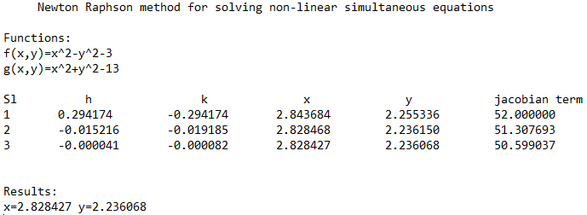

**21. Power Method**

//Program to find the eigen value of a given matrix

#include <stdio.h>

#include <math.h>

int main()

{

FILE *fp;

int i,j,order,iter=0;

printf("Enter the order of matrix:");

scanf("%d",&order); //scans the order of the matrix

fp=fopen("21.txt","w");

float A[order][order],x[order],z[order],e[order],zmax,emax; //declaring variable

printf("Enter the matrix\n");

fprintf(fp,"The given matrix is\n");

for(i=0; i<order; i++) //scanning matrix

{

for(j=0; j<order; j++)

{

scanf("%f",&A[i][j]); //scannning elements

fprintf(fp,"%f\t",A[i][j]); //print matrix in file

}

fprintf(fp,"\n");

}

fprintf(fp,"\n\n");

for(i=0; i<order; i++) //initialising first column vector

{

x[i]=1;

}

fprintf(fp,"Sl.No\tX1\t\tx2\t\tx3\t\tC\t\terrorMax\n"); //print column headers

do

{

iter++; // iteration

for(i=0; i<order; i++) //matrix multiplication

{

z[i]=0;

for(j=0; j<order; j++)

{

z[i]=z[i]+A[i][j]*x[j];

}

}

zmax=fabs(z[0]); //calculating max value

for(i=1; i<order; i++)

{

if((fabs(z[i]))>zmax)

zmax=fabs(z[i]);

}

for(i=0; i<order; i++) //divide the column matrix by c

{

z[i]=z[i]/zmax;

}

for(i=0; i<order; i++) //calculate error

{

e[i]=0;

e[i]=fabs((fabs(z[i]))-(fabs(x[i])));

}

emax=e[0];

for(i=1; i<order; i++)

{

if(e[i]>emax)

emax=e[i];

}

fprintf(fp,"%d\t%9.6f\t%9.6f\t%9.6f\t%9.6f\t%9.6f\n",iter,x[0],x[1],x[2],zmax,emax);

//printing iterations in files

for(i=0; i<order; i++) //reinitialising matrix

{

x[i]=z[i];

}

}while(emax>0.0001);

printf("The required eigen value is %f\n\n",zmax);

printf("The required eigen vector is :\n");

fprintf(fp,"\nThe required eigen value is %f\n\n",zmax); //printing results

fprintf(fp,"The required eigen vector is :\n");

for(i=0; i<order; i++)

{

printf("%f\n",z[i]);

fprintf(fp,"%f\n",z[i]);

}

return 0;

fclose(fp);

}

Output

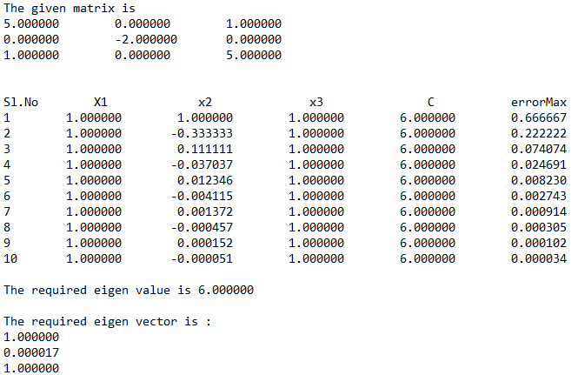

**22. Regula Falsi Method**

/*Program for implementing regula falsi method*/

#include<stdio.h>

#include<math.h>

float func(float x) //function to find the value of f(x)

{

float res;

res= exp(-x)-x;

return res;

}

int main(void) //main begins

{

FILE *fp;

fp=fopen("22.txt","w"); //file opens

int iter=1;

float a,b,c,f_a,f_b,f_c,abs_error,multi,prev_c,prev_error=0,conv;

do //taking input from user

{

printf("Enter lower and upper bound of x\n");

scanf("%f%f",&a,&b);

if(func(a)*func(b)>=0)

printf("ERROR!!! Enter again!\n");

}while(func(a)*func(b)>=0);

c=a; //for initialising a prev_c within range

fprintf(fp,"SL.no\t\ta\t\t\tb\t\t\tc\t\t\tf(c)\t\terror\torder of convergence\n");

do //loop for finding the root of the function

{

prev_c=c;

f_a=func(a); //calling the function

f_b=func(b);

c=((a*f_b)-(b*f_a))/(f_b-f_a);

f_c=func(c);

multi=f_c*f_a;

abs_error=fabs(prev_c-c);

if(prev_error!=0){

conv = log(abs_error)/log(prev_error);}

prev_error=abs_error;

fprintf(fp,"%d\t\t%f\t%f\t%f\t%f\t%f\t%f\n",iter,a,b,c,f_c,abs_error,conv);

if(fabs(f_c)<=0.000005) //checking for required precision

break;

else if(multi<0) b=c;

else a=c;

iter++;

}while(fabs(prev_c-c)>=0.000005); //checking for minimal error

fprintf(fp,"\n\nroot of the function = %f",c); //printing result in file

fclose(fp);

printf("res = %f",c); //printing result in terminal

}

Output

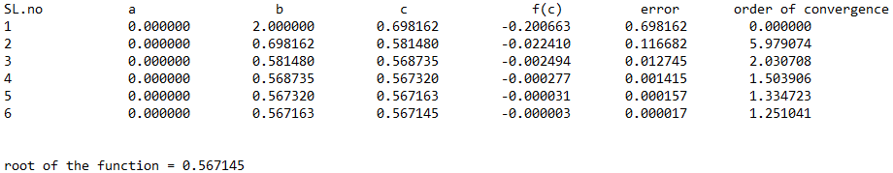

**23. Runge Kutta Method**

/*Program to apply runge kutta method for solving linear differential equations*/

#include<stdio.h>

#include<math.h>

#define f(x,y) y-x //function used :- y'=y-x

int main()

{

FILE *fp;

fp=fopen("23.txt","w"); //file opened in writing mode

fprintf(fp," Second Order runge kutta method for solving differential equation.\n\nDE: y'=y-x\n\n");

float x0,y0,m1,m2,m3,m4,m,y,x,h,xn;

printf("Enter the value of x0,xn,h,y0:\n");

//initial and final values of x, height of x and initial value of y are taken as input

scanf("%f %f %f %f",&x0,&xn,&h,&y0);

x=x0;

y=y0;

printf("\n\nX\t\tY\n");

fprintf(fp," The respective values of x and y are\n x \t y\n\n");

m=f(x0,y0)-h+h*f(x0,y0); //second orderr runga kutta formula

while(x<xn) //method application here

{

y=y+m*h;

x=x+h;

printf("%f\t%f\n",x,y);

fprintf(fp," %f\t%f\n",x,y); //printing final results at each iteration

}

}

Output

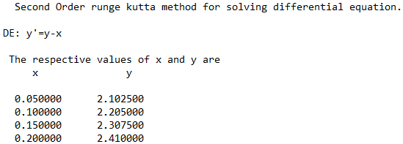

**24. Secant Method**

/*Program to apply secant method*/

#include<stdio.h>

#include<math.h>

#define f(x) exp(-x)-x //original function

int main() //main begins

{

FILE *fp;

fp= fopen("24.txt","w");

float x0,x1,x2,order,error,pre_error;

int iter=1;

fprintf(fp," SECANT METHOD\n\n");

printf("Solving Equation e^(-x)-x=0 using Secant method:\n");

printf("Please input initial approximations: ");

scanf("%f%f",&x0,&x1); //taking inputs from user

fprintf(fp,"Sl\t\tx0\t\t\tx1\t\t\tf(x0)\t\tf(x1)\t\tx2\t\t|x1-x0|\t\tOrder(c)\n");

do //method loop

{

x2=(x0*(f(x1))-x1*(f(x0)))/((f(x1))-(f(x0))); //formula to apply secant method

pre_error=fabs(x1-x0);

error=fabs(x2-x1);

order=log(error)/log(pre_error);

fprintf(fp,"%d\t%9f\t%9f\t%9f\t%9f\t%9f\t%9f\t%9f\n",iter,x0,x1,(f(x0)),(f(x1)),x2,fabs(x2-x1),fabs(order)); //printing results in the file

x0=x1;

x1=x2;

iter++;

}while(pre_error>0.0005); //condition for loop to end

fprintf(fp,"\n\nThe root of the equation is %f.\n",x1);

printf("\nThe root of the equation is: %f\n",x1); //printing final results

return 0;

fclose(fp);

}

Output

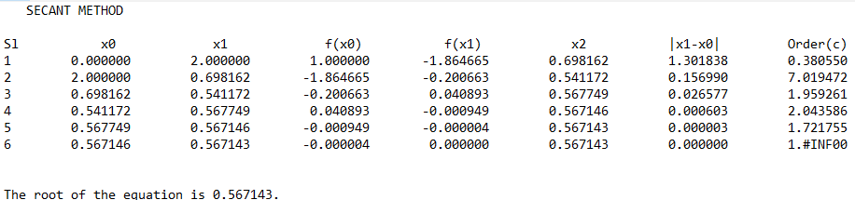

**25. Simpsons’ 1/3 Method**

/*Program to apply simpson's 1/3 method to solve a definite integrals*/

#include<stdio.h>

#include<math.h>

float f(float x) //function f=1/(1+x^2)

{

return 1/(1+x*x);

}

void main() //main begins here

{

FILE *fp;

fp=fopen("25.txt","w");

fprintf(fp," Simpson's method for solving definite integrals\n\nfunction used:- f(x)=1/(1+x^2)\n");

int i,n;

float x0,xn,h,y[20],sumo,sume,ans,x[20]; //variables declaration

printf("\n Enter values of x0,xn,h: "); //taking input for the limits of x

scanf("%f%f%f",&x0,&xn,&h);

n=(xn-x0)/h;

if(n%2==1) n++;

h=(xn-x0)/n;

printf("\n Y values: \n");

fprintf(fp,"\n Y values: \n");

for(i=0; i<=n; i++) //calculation of required values of x and y

{

x[i]=x0+i*h;

y[i]=f(x[i]);

printf("\n f(%f)=%f\n",x[i],y[i]);

fprintf(fp,"\n f(%f)=%f\n",x[i],y[i]);

}

sumo=0;

sume=0;

for(i=1; i<n; i++)

{

if(i%2==1) sumo+=y[i];

else sume+=y[i];

}

ans=h/3*(y[0]+y[n]+4*sumo+2*sume); //calculation of the final value

printf("\n Final integration is %f",ans);

fprintf(fp,"\n Final integration is %f",ans);

fclose(fp);

}

Output

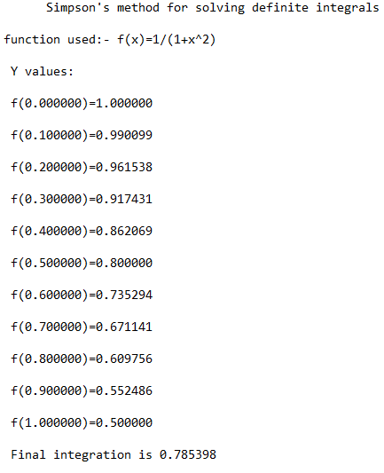

**26. Trapezoidal Method**

/*Program to integrate f(x)=1/(1+x^2) using trapezoidal rule*/

#include<stdio.h>

#include<math.h>

#define f(x) 1/(1+pow(x,2))

int main(void)

{

FILE *fp;

fp=fopen("26.txt","w");

fprintf(fp," Integrating f(x)=1/(1+x^2) using trapezoidal rule\n\n");

int i,n;

float x0,xn,h,sumo=0,sume=0,ans;

printf("\n Enter values of x0,xn,h(length of sub domain):\n");

scanf("%f%f%f",&x0,&xn,&h);

n=(xn-x0)/h;

if(n%2==1)

{

n=n+1;

}

h=(xn-x0)/n;

float x[n],y[n];

printf("\nrefined value of n and h are:%d %f\n",n,h);

printf("\n f(x) values \n"); //printing function values

fprintf(fp,"\n f(x) values \n");

for(i=0; i<=n; i++)

{

x[i]=x0+i*h;

y[i]=f(x[i]);

printf("\nf(%f)=%f\n",x[i],y[i]);

fprintf(fp,"\nf(%f)=%f\n",x[i],y[i]);

}

for(i=1; i<n; i++) //calculating integration sum

{

if(i%2==1)

{

sumo=sumo+y[i];

}

else

{

sume=sume+y[i];

}

}

ans=h/3*(y[0]+y[n]+4*sumo+2*sume); //calculating final integration sum

printf("\nfinal integration is %f",ans); //printing final result

fprintf(fp,"\n Final integration value is %f",ans);

fclose(fp);

}

Output

